11.Deploying Zoho Creator App to Production

Aim:
To understand and execute the deployment lifecycle of a Zoho Creator application, moving components from the sandboxed Development Environment to the Live Production Environment safely and efficiently.

Overview:
Zoho Creator provides distinct environments to separate application building and testing from live user operations. Proper deployment ensures data integrity and seamless release management.
Environment | Purpose & Operational Rules
Development (Sandbox) | Used for building forms, writing Deluge scripts, and testing features without impacting live data.
Production (Live) | The live environment accessed by end-users, containing active transactional data and strict access controls.
Migration & Publish | The controlled process of pushing schema changes, workflows, and configurations from Dev to Prod.

Procedure:
- Pre-Deployment Validation: Open your fully tested application in the Zoho Creator development workspace. Verify that all Deluge scripts, workflow triggers, and reports are fully functional.
- Initiating Migration: Navigate to the deployment manager or settings menu and select the option to push or migrate changes to the production environment.
- Reviewing Schema & Component Diffs: Inspect the comparison report generated by Zoho Creator, which highlights newly added forms, modified fields, or updated script blocks.

Screenshots:

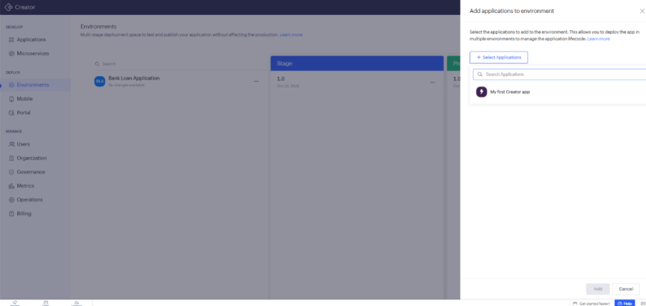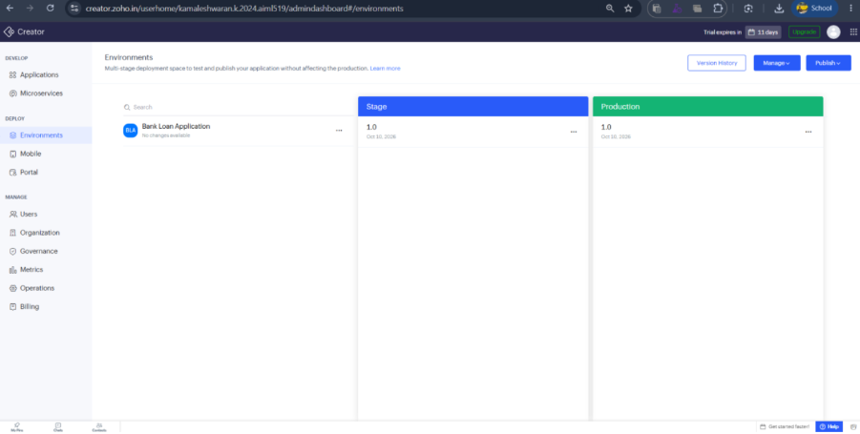

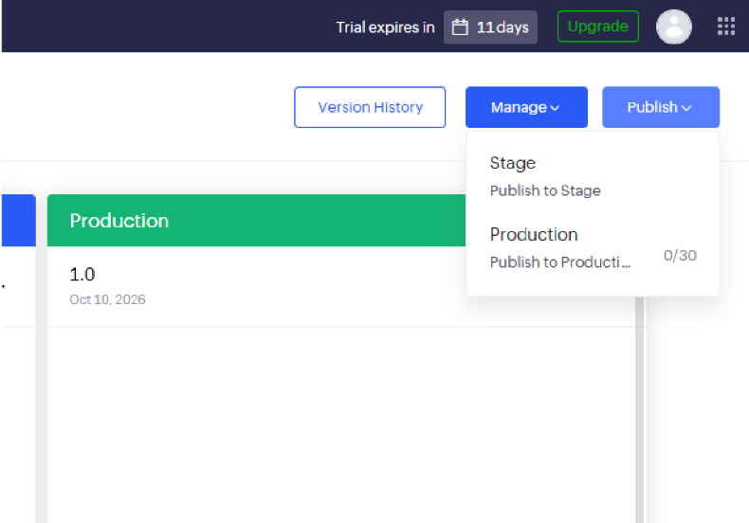

Result:
The deployment lab successfully demonstrated the transition lifecycle of a low-code application from development to production in Zoho Creator, emphasizing safe release management and environment isolation.

